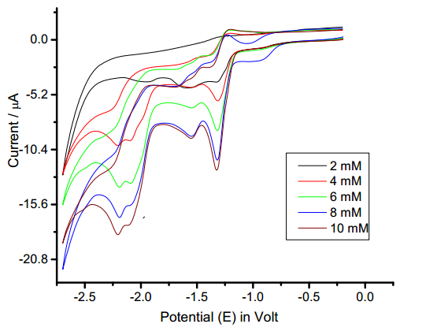

Fig. . Cyclic voltammograms of (E)-1-(furan-2-yl)-3-phenylprop-2-ene-1-

ones in tetra butyl ammonium tetra fluoroborate.

Solvent = acetonitrile; Sweep rate = 40 mV/s ; working electrode = glassy carbon

[substrate] =